**Bin It**

It is a map-based application that helps locate trash bins in the vicinity. Linked to Google Maps, it can be used anywhere. All users can add the bins to the app database. (If one comes across a dustbin that is not listed in the app, the user can add that dustbin in the app database by pressing add button and clicking its picture.)

These technology can provide visibility on solid waste management, route planning for garbage collection, resource optimization, efficient asset management, efficient maintenance, visibility of waste bins etc.

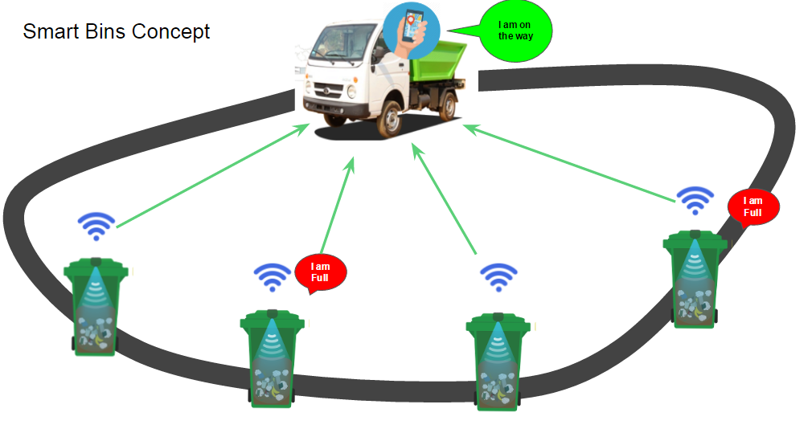

The goal of the app is to collate locations of all trash bins in ones locality, encouraging people to use them instead of throwing stuff anywhere.